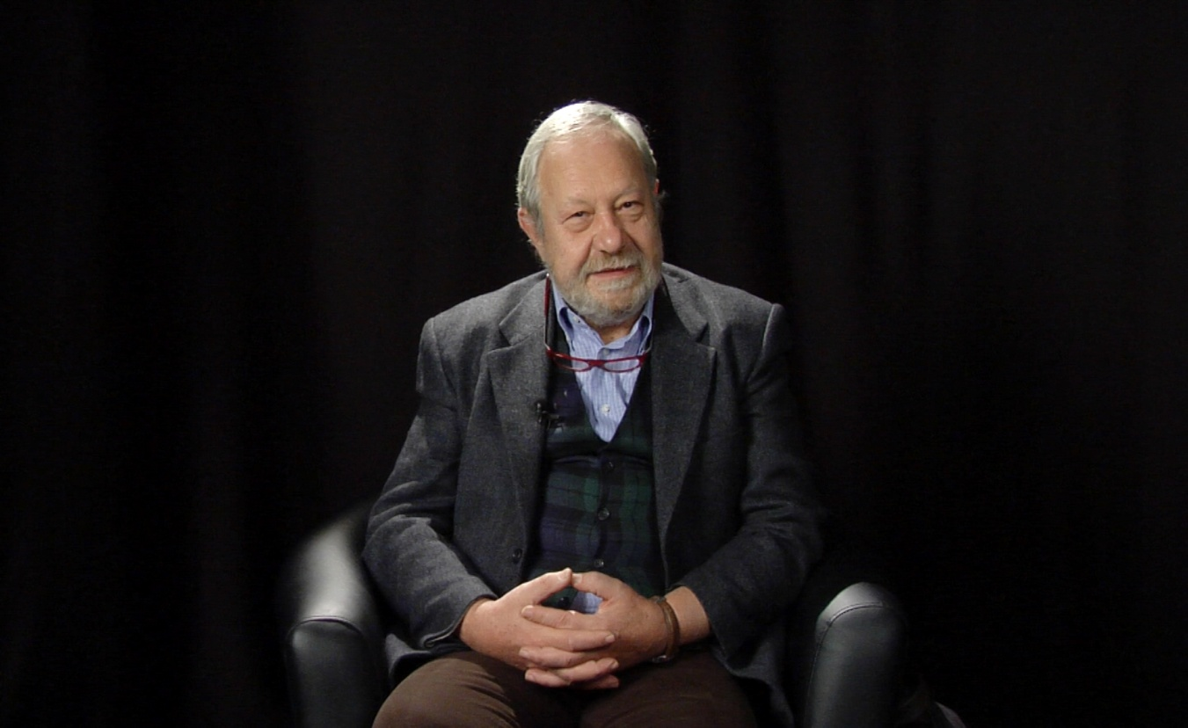
Rodolfo BAGGIO
Rodolfo holds a Laurea degree in Physics (MPhys) from the University of Milan (Italy) and a PhD in Tourism from the University of Queensland (Australia). In 2014 he has received the Italian National habilitation to associate professorship in Applied Economics for the period 2014-2020.
After having performed research and teaching activities in Astrophysics and Radioastronomy, he joined IBM Italy (1978) where he held several professional positions in the area of large systems, with main activities in information systems design, marketing and managerial education, and managerial positions in technical and marketing areas. He has also worked in Germany (IBM Mainz plant) as marketing support manager. In 1991 Rodolfo is at the Merzario Group (logistics and transportations) as Director of the group’s Information Systems department and of the headquarter’s Organization and Supply Management department.
Since 1999 Rodolfo is professor (contracted) at the Bocconi University (Milan) where he teaches courses in computer science, information technology and systems, and quantitative research methods. At Bocconi he is coordinator of the Information and Communication Technologies area at the Master in Economics and Tourism and research fellow at the DondenaCenter for Research on Social Dynamics.
He is also Visiting Professor at Bournemouth University (UK), Visiting Associate Professor at the University of Primorska (Koper, Slovenia), and Visiting Professor at the Tomsk Polytechnic University, Tomsk, Russia. He has been deputy director of the GTAT Tourism Policy and Strategy postgraduate courses organized by the UN World Tourism Organization – Themis Foundation and visiting lecturer at the EuroArab Management School (Granada, Spain), Master in Tourism Management (course held in Beirut, Lebanon and Aqaba, Jordan). He has taughtat the MBA in International Hospitality Management of the IMHI-ESSEC business school (Paris, France) and at the University of Primorska (Koper, Slovenia). Recently he has lecturedat: the FachHochschule in Salzburg, Austria, the Arab Academy for Science, Technology & Maritime Transport, Alexandria, Egypt, the Higher School of Economics,Moscow, Russia,and the European Tourism Research Institute (ETOUR), Mid Sweden University, Östersund, Sweden.
Rodolfo has carried out research and consulting activities in the field of information technologies, organization, and planning for private and public tourism organizations and has managed several international research projects dealing with tourism destinations management and territorial planning. More recently, his research interests have centred on the analysis of the social and technological network structures underlying the tourism activities and on the application of complexity theory and network analysis methods to the study of tourism destinations. He has held several lectures in national and international conferences and authored numerous scientific and popular articles and books.
Rodolfo is member of the scientific board of several international conferencesand scholarly journalsand serves asassociate editor of the Journal of Information Technology and Tourism and the International Journal of Tourism Sciences, and as editor of the letters section Current Issues in Tourism. He has chaired the Information Technology and Tourism cross session at the IFIP (International Federation for Information Processing) World Computer Congress (Milan, 2008), the Industry Track at Enter 2010 and 2011,the PhD Workshop at Enter 2014. and the ENTER2012 conference in Helsingborg, Sweden. He has been Vice President of IFITT (International Federation for IT and Travel & Tourism) in 2012-2013 and is president of the Italian chapter since 2011
Rodolfo is founding member of Società Internet, the Italian chapter of the Internet Society and member of the Italian Physical Society, of IFITT (past vice-president and president of the Italian chapter), and Fellow of the Royal Geographical Society. In 2017 he has been awarded the Hannes Werthner Lifetime Achievement Award from IFITT (International Federation for Information Technology and Travel & Tourism)

Rodolfo Baggio, PhD FRGS
rodolfo.baggio@unibocconi.it

Full publications list: http://goo.gl/mAE2vN(selected full texts: http://goo.gl/iP3dS)Google Scholar profile: http://goo.gl/NPihN); ORCID: http://orcid.org/0000-0001-9207-9665

Rodolfo Baggio–Main Publications

(Google Scholar profile at: http://goo.gl/NPihN)
ORCID (Open Researcher and Contributor ID) http://orcid.org/0000-0001-9207-9665

Books
and Development: The Importance of Networks and ICTs. New York: Palgrave McMillan.
Baggio, R., Klobas, J. (2017 - 2011). Quantitative research methods in tourism: a handbook. Bristol, UK: Channel View. (second edition in print)
Mariani, M. M., Baggio, R., Buhalis, R., & Longhi, C. (Eds.). (2014). Tourism Management, Marketing
Baggio, R., Antonioli, M. (2011). Internet e Turismo 2.0. Milan: EGEA.
Scott, N., Baggio, R., & Cooper, C. (2008). Network Analysis and Tourism: From Theory to Practice. Clevedon, UK: Channel View.

Journal papers& book chapters
Amelung, B., Student, J., Nicholls, S., Lamers, M., Baggio, R., Boavida-Portugal, I., Johnson, P., de Jong, E., Hofstede, G.-J., Pons, M., Steiger, R., &Balbi, S. (2016). The value of agent-based modelling for assessing tourism-environment interactions in the Anthropocene. Current Opinion in Environmental Sustainability, (forthcoming).
Johnson, P., Nicholls, S., Student, J., Amelung, B., Baggio, R., Balbi, S., Boavida-Portugal, I., de Jong, E., Hofstede, G.-J., Lamers, M., Pons, M., &Steiger, R. (2016). Easing the adoption of agent-based modelling (ABM) in tourism research. CurrentIssues in Tourism, (doi: 10.1080/13683500.2016.1209165).
Baggio, R., & Moretti, V. (2016). La bellezza come fattore di sviluppo economico e sociale. Scienze e Ricerche, 4(28), 63-74.
Baggio, R., &Sainaghi, R. (2016). Mapping time series into networks as a tool to assess tourism systems’ complex dynamics. Tourism Management, 54, 23–33
Clemente, F., Nasuelli, P. A., &Baggio, R. (2015). Formal network analysis of a food supply chain system: a case study for the Italian agro-food chains. Journal of Agricultural Informatics, 6(4), 1-16.
Del Chiappa, G., &Baggio, R. (2015). Knowledge transfer in smart tourism destinations: analysing the effects of a network structure. Journal of Destination Marketing and Management, 4(3), 145-150.
Mich, L., &Baggio, R. (2015). Evaluating Facebook pages for small hotels: a systematic approach. Information Technology and Tourism, 15(3), 209-231.
Turci, L., Pennec, S., Toulemon, L., Bringé, A., Baggio, R., &Morand, E. (2015). Agent-based microsimulation of population dynamics. In M. Bierlaire, A. de Palma, R. Hurtubia& P. Waddell (Eds.), Integrated Transport & Land Use Modeling for Sustainable cities (pp. 113-135). Lausanne, CH: EPFL Press.
d’Amore, M., Baggio, R., & Valdani, E. (2015). A practical approach to big data in tourism: a low cost Raspberry Pi cluster. In I. Tussyadiah& A. Inversini (Eds.), Information and Communication Technologies in Tourism 2015 (Proceedings of the International Conference in Lugano, Switzerland, February 3-6) (pp. 169-181). Berlin - Heidelberg: Springer.
Aubke, F., Wöber, K., Scott, N., &Baggio, R. (2014). Knowledge Sharing in Revenue Management Teams: Antecedents and Consequences of Group Cohesion. International Journal of Hospitality Management, 41, 149-157.
Sheresheva, M., &Baggio, R. (2014). Setevoypodkhod v izucheniituristicheskikhdestinatsiy: novyyetendentsii (Network approach in the study of tourist destinations: new trends, in Russian). Initsiativy XXI veka, 2014(2), 58-63.
Grama, C.-N., &Baggio, R. (2014). A network analysis of Sibiu County, Romania. Annals of Tourism Research, 47(1), 89-93.
Sainaghi, R., &Baggio, R. (2014). Structural social capital and hotel performance: is there a link? International Journal of Hospitality Management, 37, 99-110.
Baggio, R. (2014). Complex tourism systems: a visibility graph approach. Kybernetes, 43(3/4), 445-461.
Baggio, R., & Del Chiappa, G. (2014). Real and virtual relationships in tourism digital ecosystems. Information Technology and Tourism, 14(1), 3–19.
Baggio, R. (2013). Oriental and occidental approaches to complex tourism systems. Tourism Planning and Development,10(2), 217-227.
Baggio, R. (2012). Food consumption, cognitive functions and Nobel laureates. Annals of Improbable Research online (November 19). Retrieved November, 2012, from http://www.improbable.com/2012/11/19/its-not-just-chocolate-foods-and-nobel-laureates/.
Baggio, R., &Sainaghi, R. (2011). Complex and chaotic tourism systems: towards a quantitative approach. International Journal of Contemporary Hospitality Management, 23(6), 840-861.
Baggio, R., Mottironi, C., &AntonioliCorigliano, M. (2011). Technological aspects of public tourism communication in Italy. Journal of Hospitality and Tourism Technology, 2(2), 105-119.
Baggio, R. (2011). Collaboration and cooperation in a tourism destination: a network science approach. Current Issues in Tourism, 14(2), 183-189.
Baggio, R., Scott, N., & Cooper, C. (2010). Improving tourism destination governance: a complexity science approach. Tourism Review, 65(4), 51-60.
Baggio, R., Scott, N., & Cooper, C. (2010). Network science - a review with a focus on tourism. Annals of Tourism Research, 37(3), 802-827.
Baggio, R., & Cooper, C. (2010). Knowledge transfer in a tourism destination: the effects of a network structure. The Service Industries Journal, 30(10), 1-15.
da Fontoura Costa, L., &Baggio, R. (2009). The Web of Connections between Tourism Companies: Structure and Dynamics. Physica A, 388, 4286-4296.
Baggio, R. (2008). Symptoms of complexity in a tourism system. Tourism Analysis, 13(1), 1-20.
Scott, N., Cooper, C., &Baggio, R. (2008). Destination Networks - Theory and practice in four Australian cases. Annals of Tourism Research, 35(1), 169-188.
Baggio, R. (2007). The Web Graph of a Tourism System. Physica A 379(2), 727-734.
Baggio, R. (2006). Complex systems, information technologies and tourism: a network point of view. Information Technology and Tourism, 8(1), 15-29.

Conference presentations (invited & keynotes)
ENTER2015 PhD Workshop, February 2015, Lugano, CH
ISCONTOUR 2014: 2nd International Students Conference in Tourism Research, 5 May 2014. IMC University of Applied Sciences.Krems, Austria
IFITT Doctoral Summer School, 8-10 July, 2013. Bournemouth, UK
Annual International Conference of the Royal Geographical Society (session: Lost in translation - Western tourism theory meets non-Western tourists, Geography of Leisure and Tourism Research Group). Edinburgh, 3-5 July 2012
Travel Zoom: 2nd Conference on Strategic and Creative Marketing in Tourism, 21-23 March, 2012. Bled, Slovenia.
European Institute for Advanced Studies in Management (EIASM): 1st International Conference on Tourism Management and Tourism Related Issues, 15-16 September, 2011. Rimini, Italy.
1st International Conference on Tourism & Technology (ICTT): Next Generation Technology Solutions, 7-9 July, 2011. Delhi, India.
Encuentros: Tourism and Quality of Life, September 27-28, 2010. Portorož, Slovenia.

Working papers (refereed)
Baggio, R. (2015). Looking into the future of complex dynamic systems (MPRA no. 65549). Munich Personal RePEc Archive.Online at: http://mpra.ub.uni-muenchen.de/65549/.
Baggio, R., &Moretti, V. (2015). Beauty as a factor of economic and social development (MPRA no. 66194). Munich Personal RePEc Archive.Online at: http://mpra.ub.uni-muenchen.de/66194/.
Baggio, R. (2008). Tourism networks and computer networks (arXiv/physics/0801.2196).Online at: http://arxiv.org/abs/0801.2196.

